Date:
LO: To use repetition to control physical outputs.

What would the algorithm for the alternating flash pattern be⊗⊗ | ⊗⊗ | ⊗⊗ | ⊗⊗?

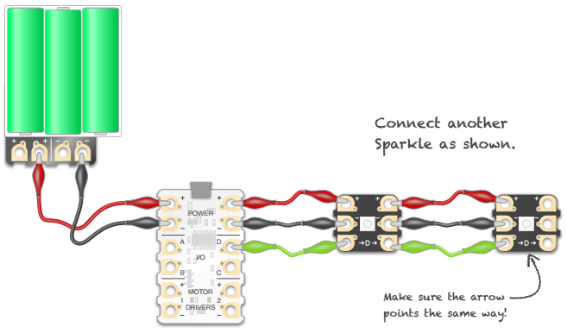
You need to connect up your Sparkles as shown on the following diagram:

What block do you need to light up the sparkles?

If you were to light up a third Sparkle, what number would you have to add in the block?

