Date:
LO: To use an input to control an output
- Can you make your sparkle flash once every two seconds?

- What is the light sequence I’ve been give:

- What is the algorithm for my code going to be?
________________________________________________________________________________________________________________________________________________________________________________________________________________________________________________________________________________________________________________________________________________________________________________________________

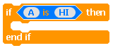
- Useful block for a toggle switch:

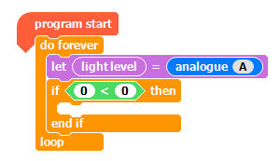
- Lighthouses usually turn on when it gets dark enough. We can use a light-dependant resistor (LDR) to achieve this. The following block of code should help you use the LDR within your project.

Print these out and cut them up.
------------------------------------------------ 5s -----------------------------------------------

------------------------------------------------ 9s -----------------------------------------------

----------------------------------------------- 10s -----------------------------------------------

------------------------------------------------ 4s -----------------------------------------------

------------------------------------------------ 8s -----------------------------------------------

