Date:
LO: To use an input to control an output

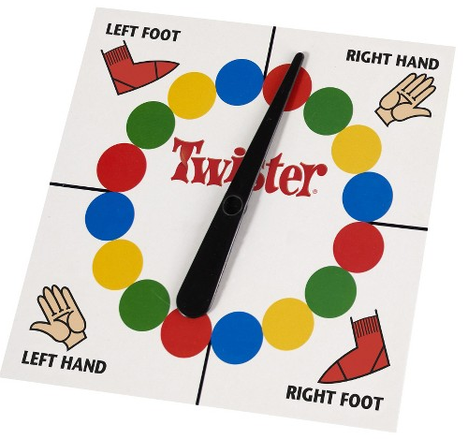
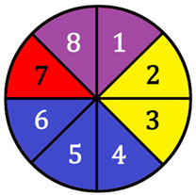

See PowerPoint for image credits

- What is the chance (probability) of getting each colour?

Red –  Purple –  Yellow –  Blue - | Red –  Yellow –  Green –  Blue -
- Algorithm for a spinner:
- Draw the block to control the motor:

- Greater Depth – can you make your spinner more realistic?
hint: they slow down gradually!

