N.B. Depending on the motors you have, and how you connect them, your code is likely to be slightly different.
Possible Solutions
CRD Buggy Two: Line Drawing
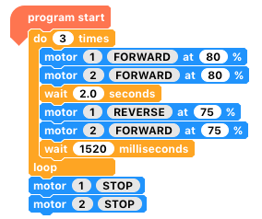
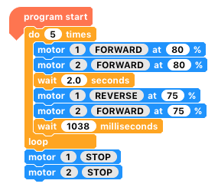
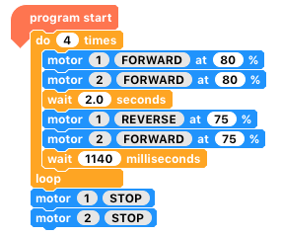

Equilateral Triangle
Pentagon
Square

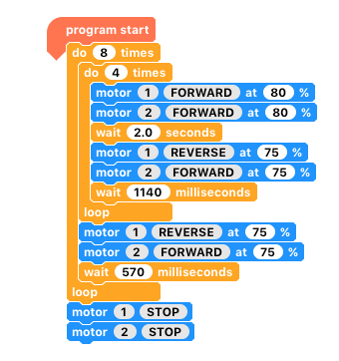

This is the Spirograph style pattern. It is in fact the program for a square, repeated 8 times, but after it has drawn one square it turns 45 degrees.

CRD Buggy Three: Bump and Reverse
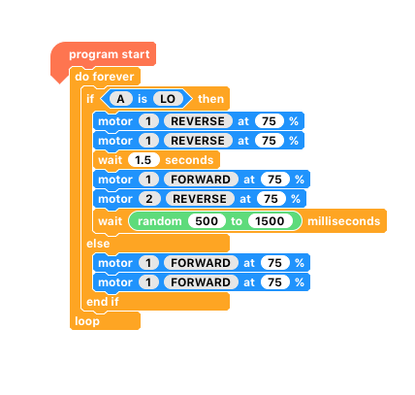

This is the code for the bump and reverse program, where it turns for a random amount of time.

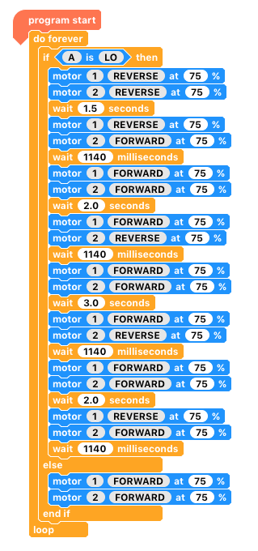

This is the code for the bump and reverse program, where it aims to go around the object (Q.11)

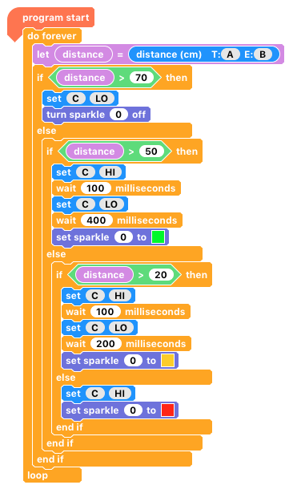
CRD Buggy Four: Reverse Parking Sensor
This is the code for the reverse parking sensor, with the addition of a Sparkle.
This is the code for the reverse parking sensor.
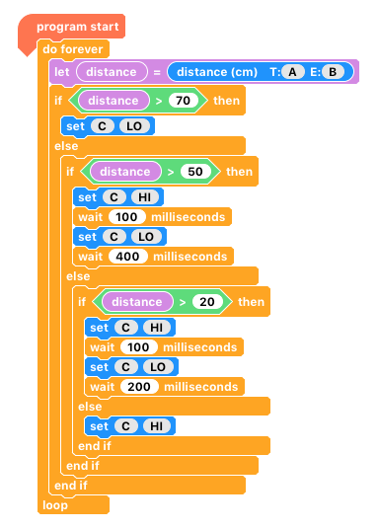

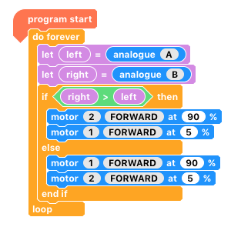
CRD Buggy Five: Line Following

This is the basic code for a line following buggy. The motor speeds (%) can vary, although the faster the slower motor, the more likely it is to ‘fall off’ at a corner.

The program can be adapted for a white line on a black background by changing

or

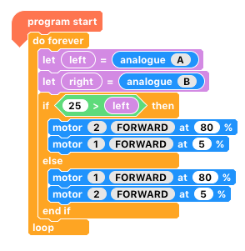

The program can be adapted for a white line on a black background by changing the condition ‘left < 25’ to ‘left > 25’ .

