Card Bot: Bump and Reverse

1) Hopefully you have a working buggy, which can move in all directions. Now we are going to turn it into an autonomous vehicle!

2) First of all, you need to fold the cardboard piece and attach it to your micro-switch like this. Make sure that the words are the correct way up.

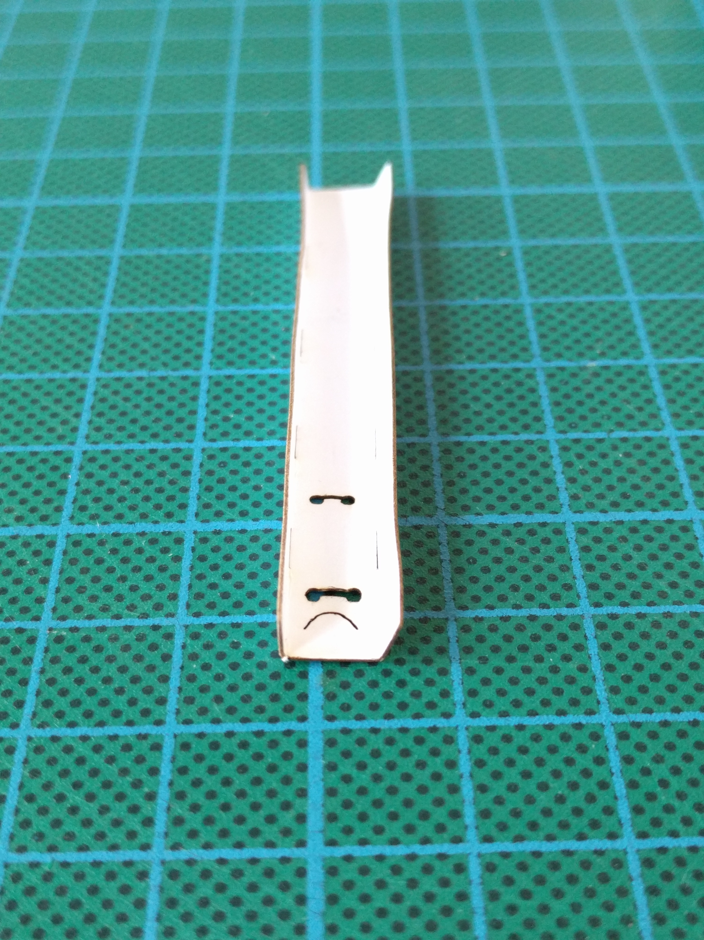
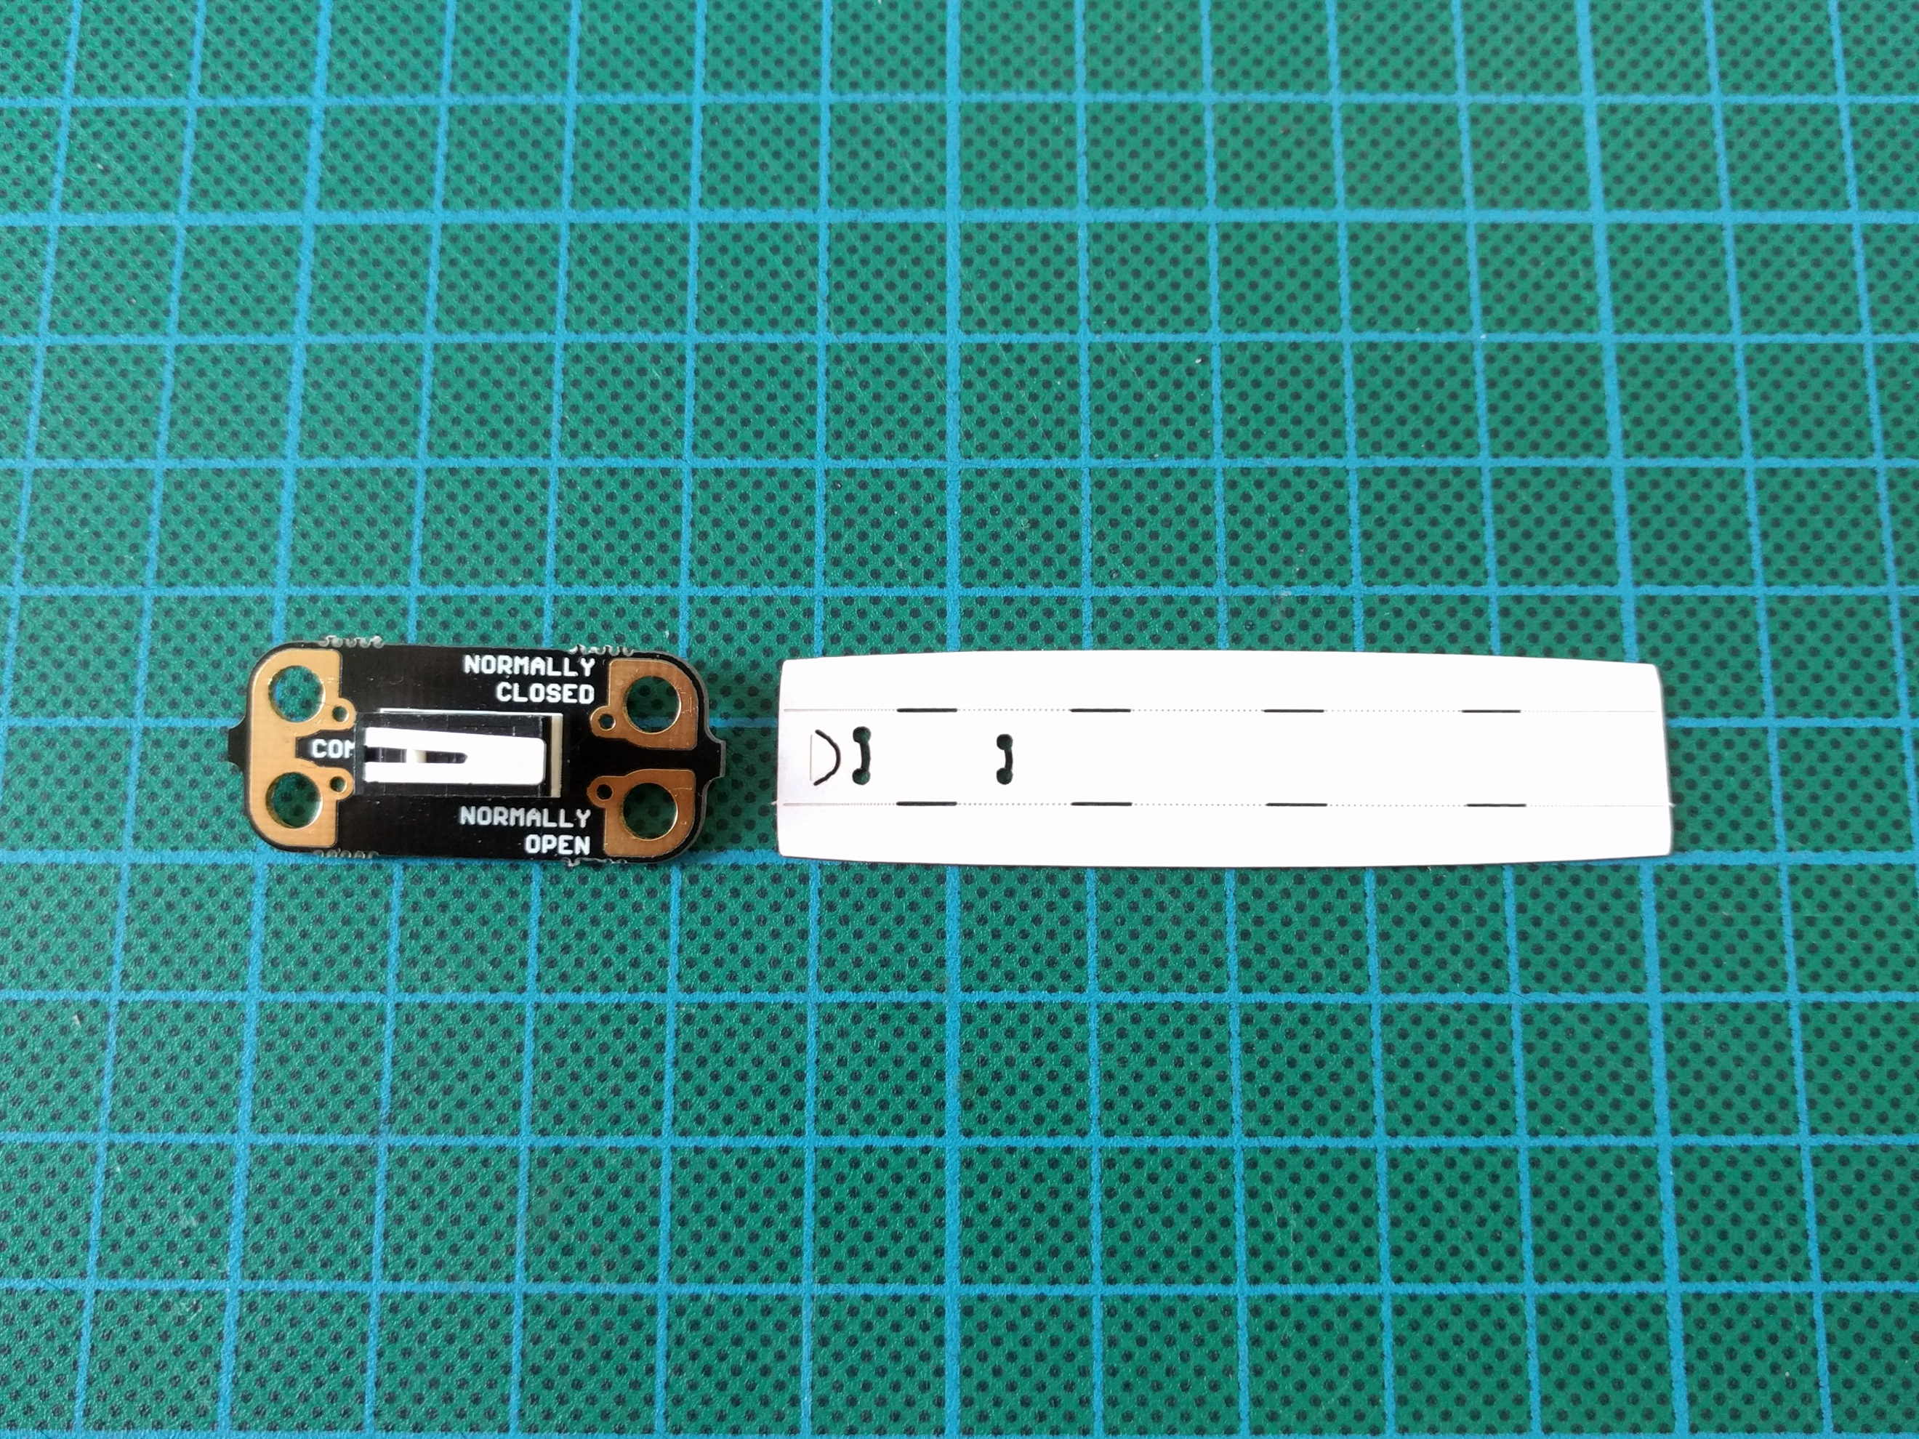
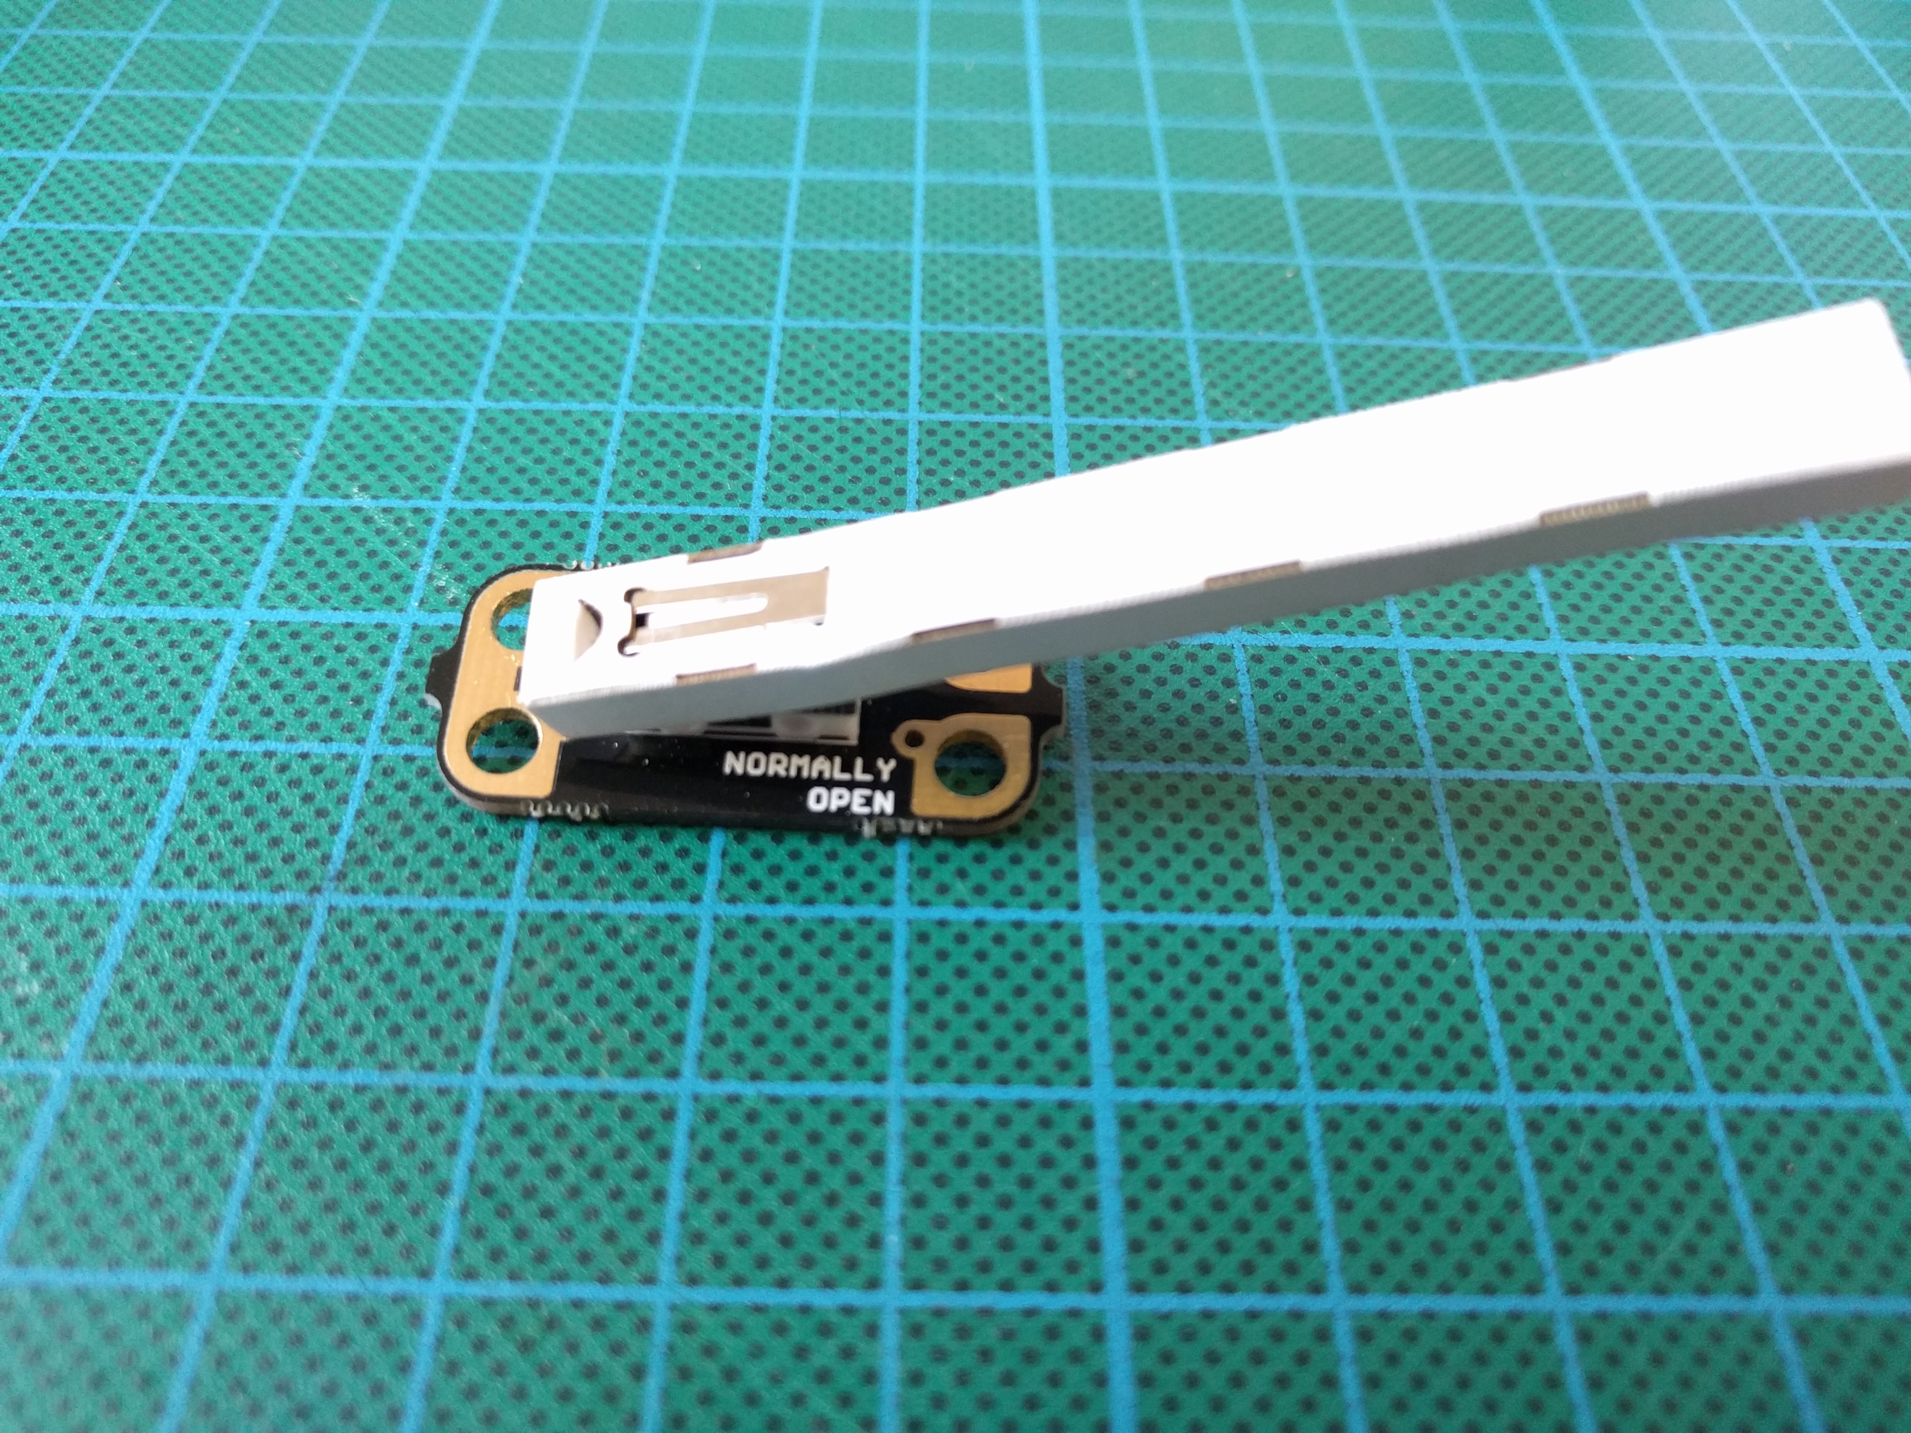

3) Now we are going to attach this to the chassis. We are going to use the croc-clips to help hold it in place on the front-left of the buggy. The com (common) pad can connect to the + output on the Crumble (or battery) and the ‘NORMALLY CLOSED’ pad needs to connect to A (or B, C, D).

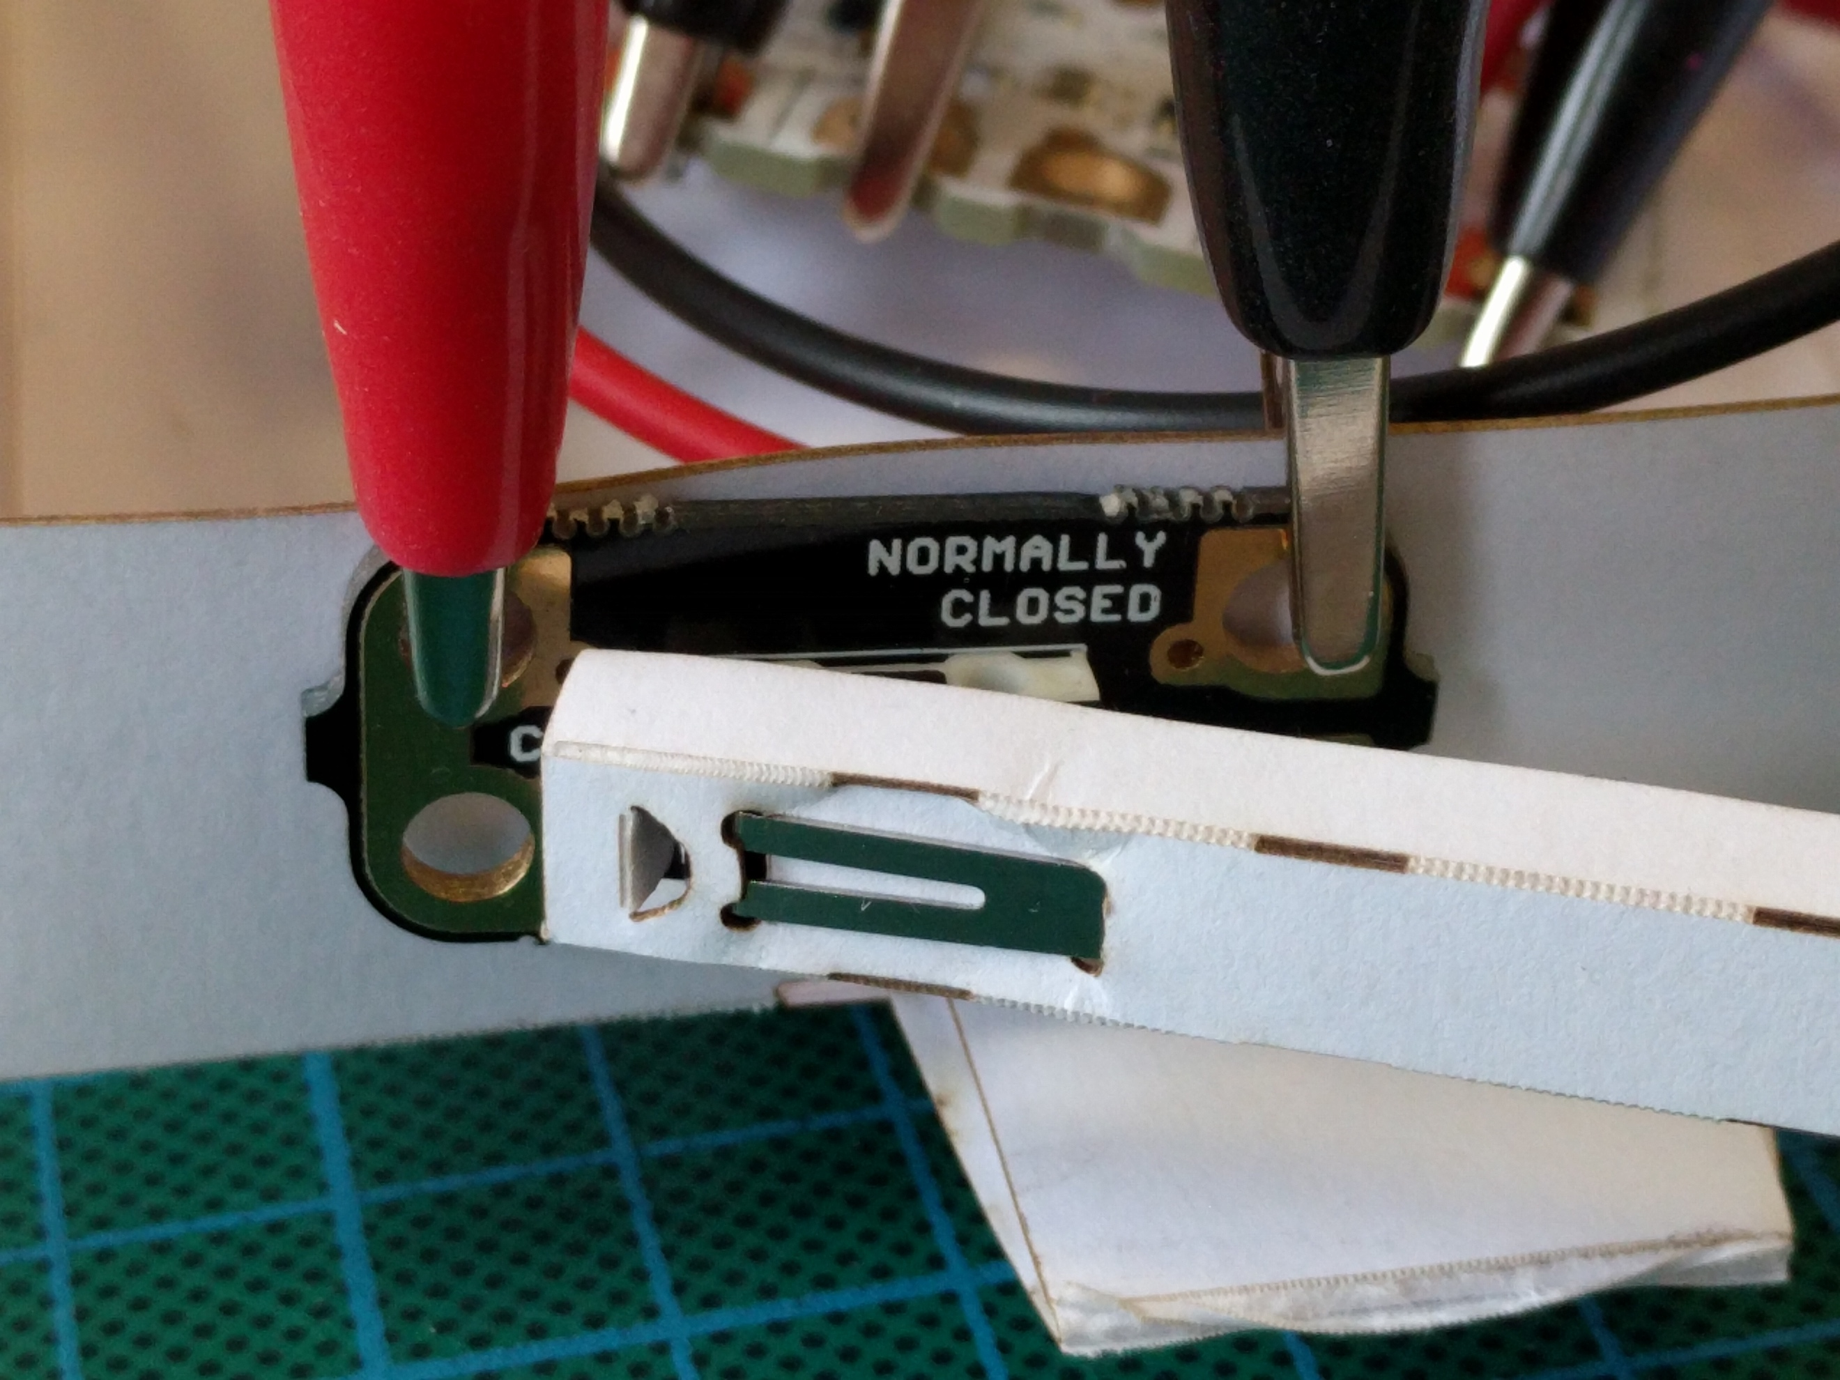

4) Now we need to think about what we want our buggy to do if it bumps into something (an obstacle in the way). If it bumps into an object, we want it to reverse, turn a bit and then drive forwards.
hint: we reverse to help reduce the possibility of the cardboard bar catching on an object when turning.

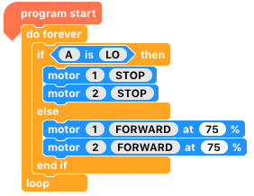

5) We are going to use the ‘If else’ block. If the switch is pressed down (‘A is LO ‘- as it is connected like a push-to-break switch) stop. Else, keep driving forwards. Run this and see what happens.

hint: click the motor number or ‘FORWARDS’ to change the choices.

6) We want the buggy to do more than just stopping when it bumps into something. What can you add in to make it reverse for 1.5 seconds (1500 milliseconds). What do you adjust to make it reverse further?

7) Now we need to add in a turn. You can add in either a gradual or on-the-spot turn, it’s up to you. Where would the turn go within the previous code?

8) How do you make your buggy turn a bigger/smaller angle? Try it out.

9) And there we have it, a simple and autonomous bump and reverse buggy!

10) We can use the random function to randomly choose the turn size. Where would it go in your code? Try it out and see what happens.

11) Imagine you were to put obstacles in the way of your buggy. How could you make it go around the obstacle and continue on its path?

12) What would happen if the object was much bigger, and the buggy drove into it whilst going around it? How could you improve your code so that it could deal with any object?

Where next?
Using a micro-switch in this way is great for sensing a physical input, and it allows you to easily create a simple Bump and Reverse buggy. The next step on for this project would be to use an ultrasonic distance sensor instead.

