Card Bot: Getting It Moving
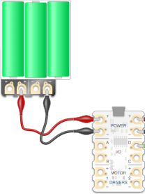
1) First of all, you need to build your CRD Buggy (see separate instructions).

2) Connect the battery pack to the Crumble (keep it turned off for now).

3) Attach the left motor (as you look at it) on the buggy to the motor two pads on the Crumble. Red to + and black to -.

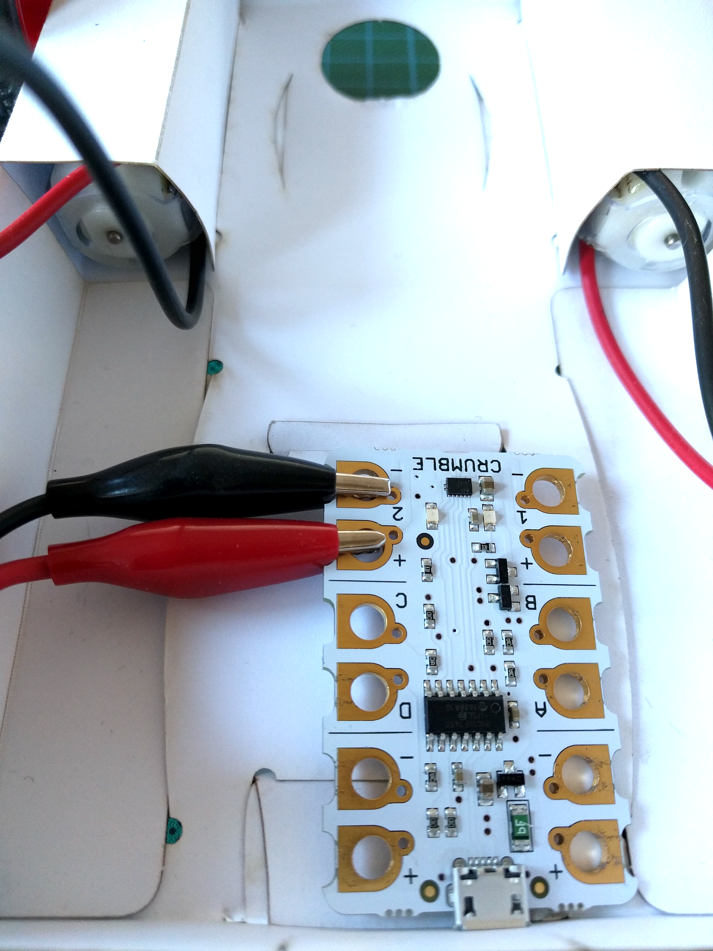

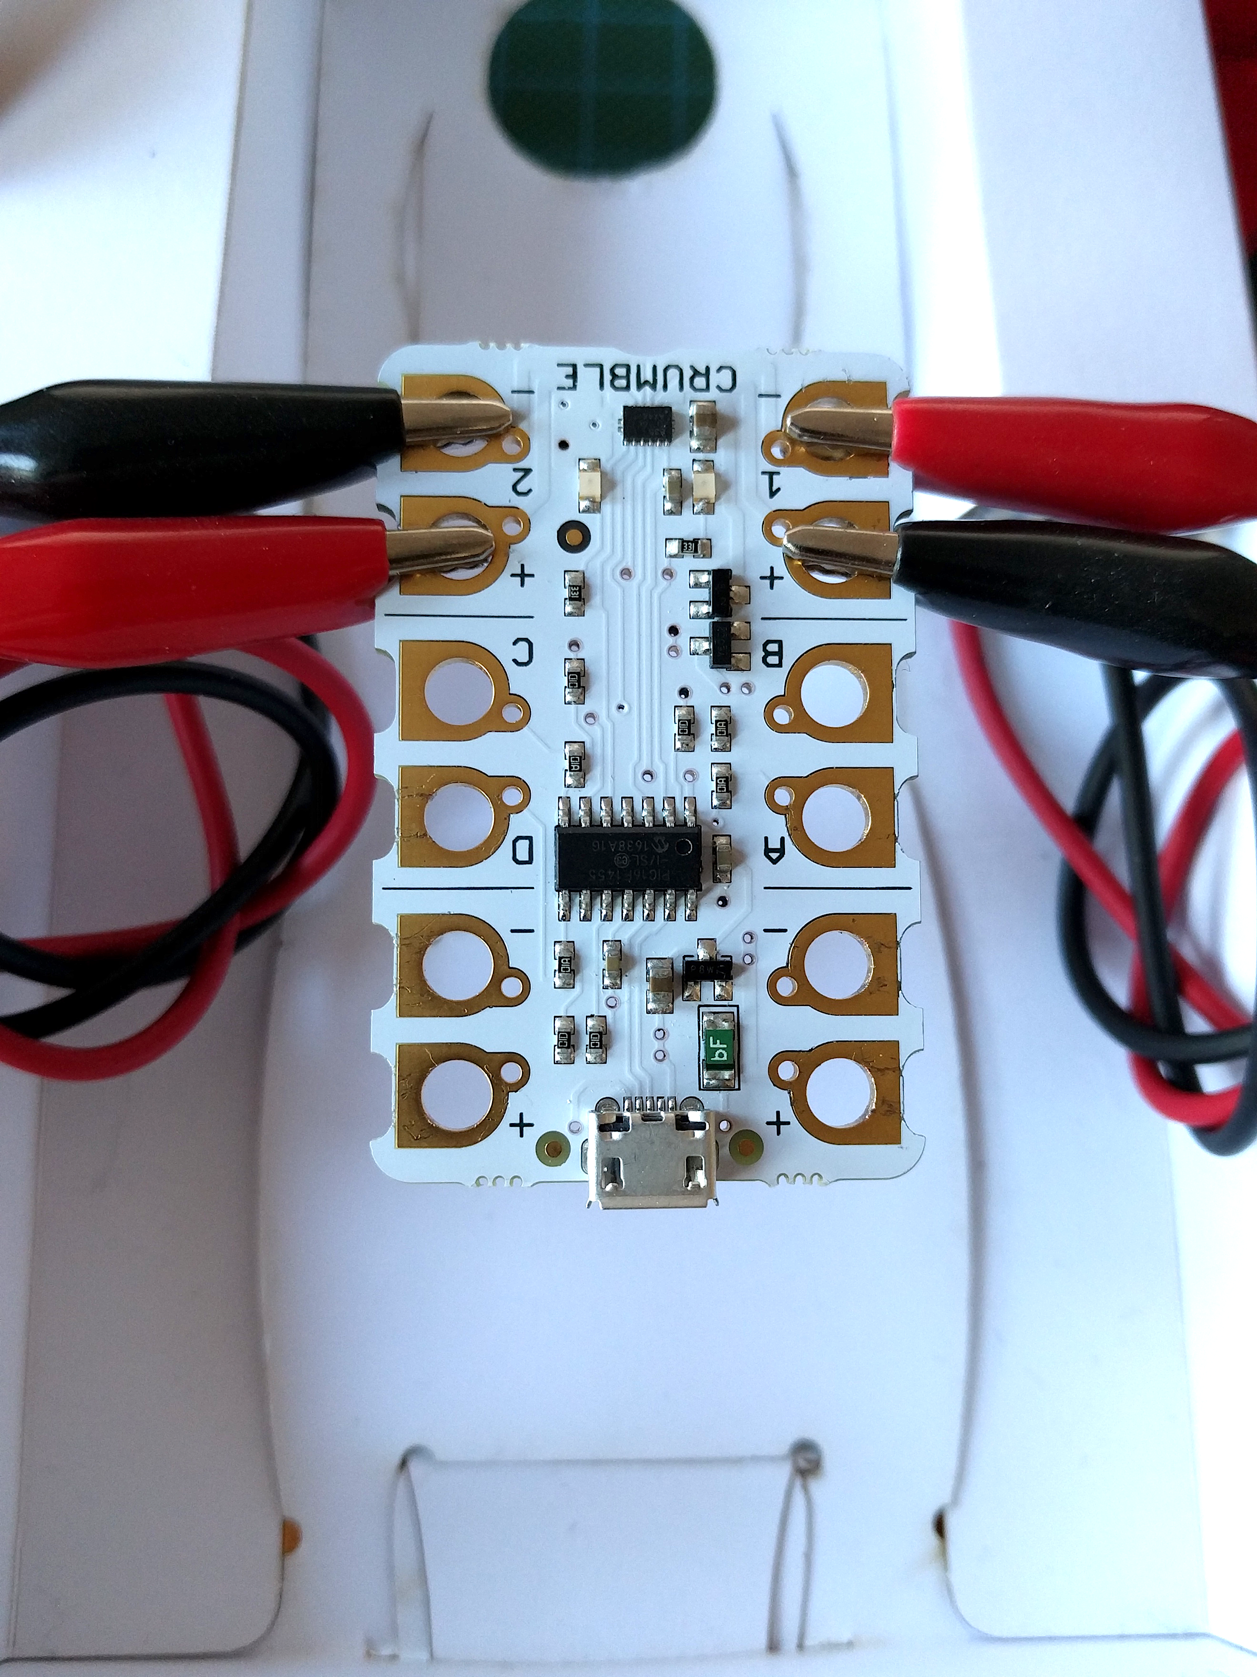
4) Next, we need to attach the right motor to the motor one pads on the Crumble. We are going to reverse the way this is connected to the Crumble. As the motor is flipped over, it will turn in the opposite direction, so this time we need to connect red to – and black to +.


5) Plug the Crumble into the computer and open the Crumble software.

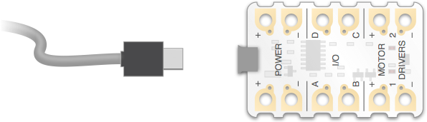


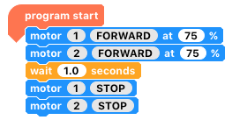
6) Now we are going to flash the on-board motor lights. Leaving the battery pack off, run the following code by clicking the green triangle at the top.

7) Unplug your micro-USB lead, and turn on the battery pack. It’s alive!

.

8) Getting the buggy to move backwards instead is simple. Turn off the batteries, plug it in and change the motor blocks to ‘REVERSE’ instead of ‘FORWARDS’. Click play and you’re done! Unplug it and turn on the batteries. Did it go the opposite way?

.

hint: click the word to change it between forward, reverse and stop.

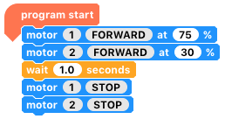
9) But what about turning? There are two main ‘turn types’ that we can program; gradual or on-the-spot. For a gradual turn, one motor simply needs to be slower than the other. Before trying the following code, which way do you think it will turn?

.

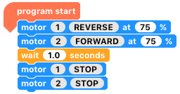
10) Turning on the spot is just as easy. We want one motor to go forwards, and the other to go backwards. Which way will the buggy turn this time?

.

11) Can you make your buggy drive, turn around and come back exactly where it started?

.

12) Place an object at least 50cm away, behind your buggy. Can you make your buggy touch the object?

Where next?
There is a lot of potential for a Card Bot Crumble Buggy and getting it to move around is just the start. You could navigate courses, make it remote control, make it autonomous or even adapt or design your own!

*To download these resources and more, please visit www.redfernelectronics.co.uk/cardtrial *

