Card Bot: Line Drawing

1) To get our Line-Drawing Buggy working, we need to connect the pen clip and pen as shown.

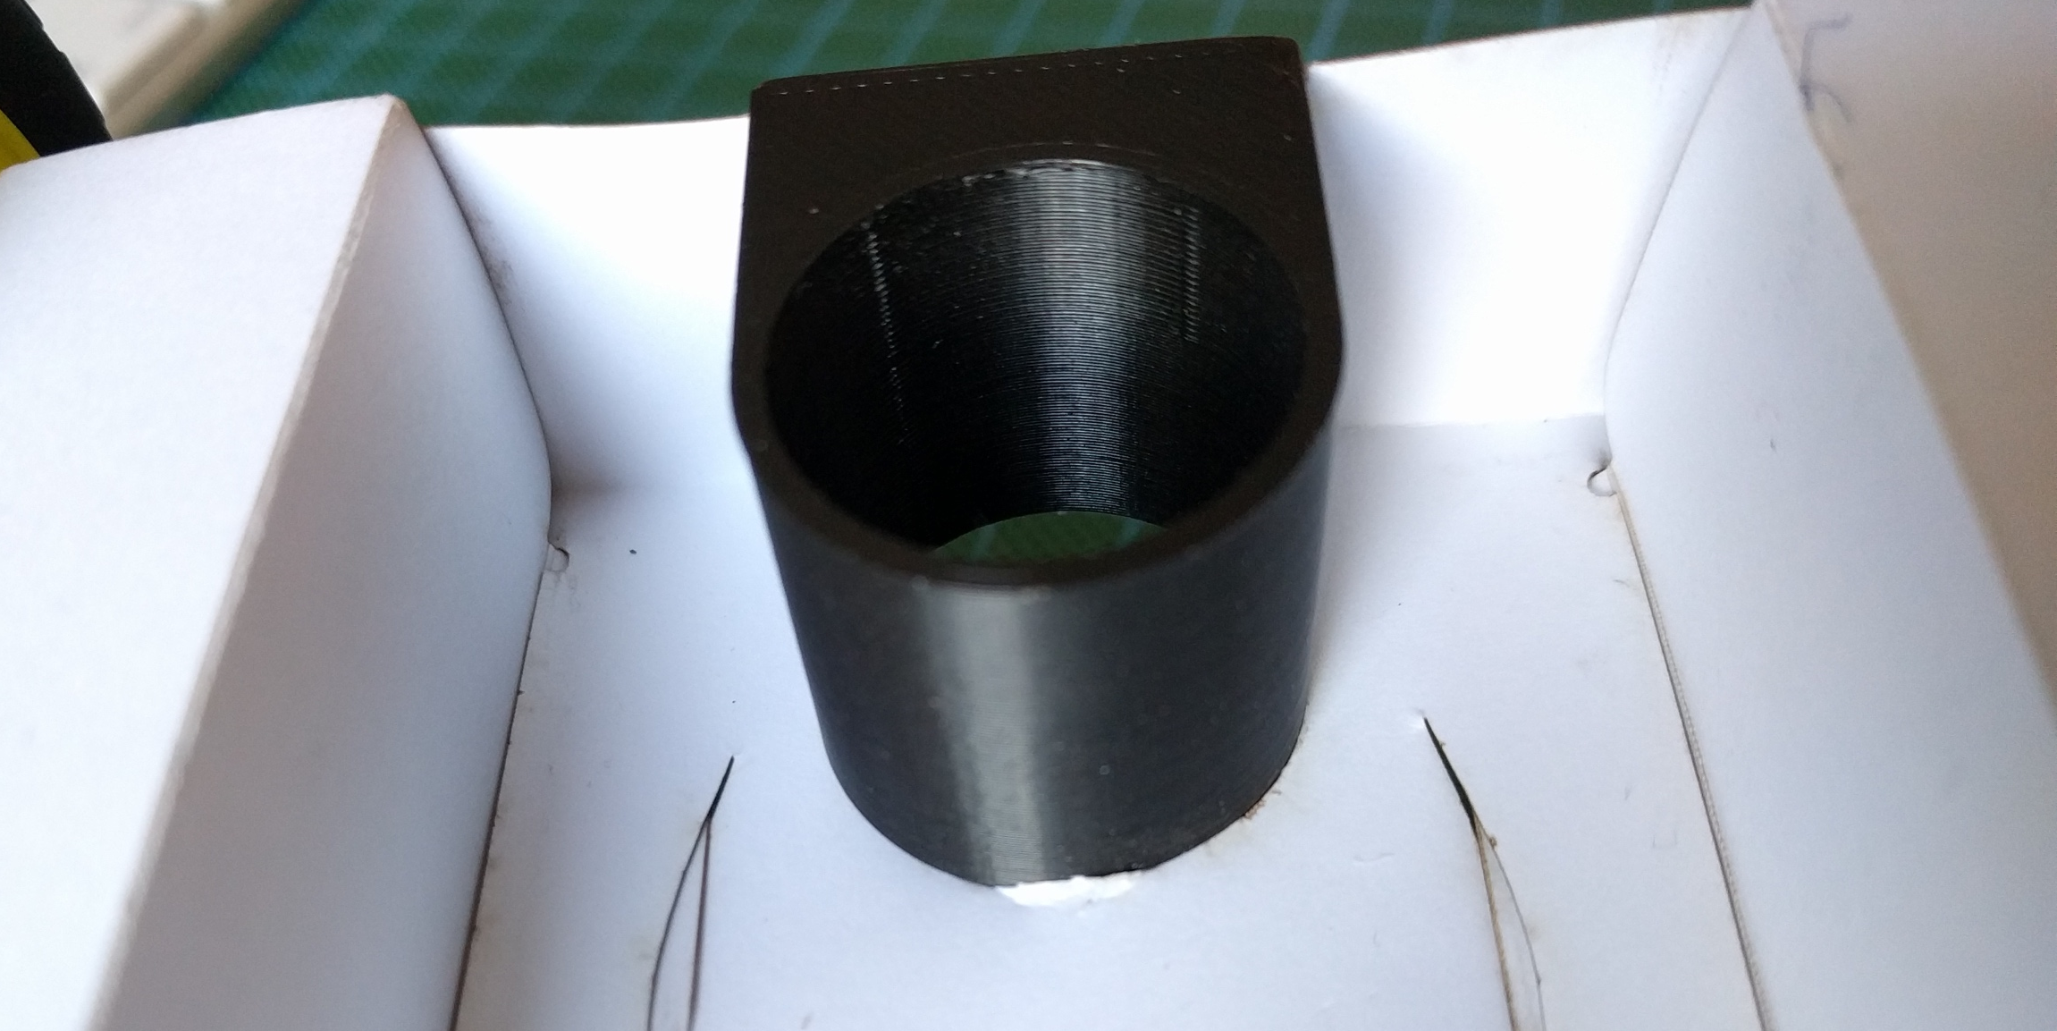

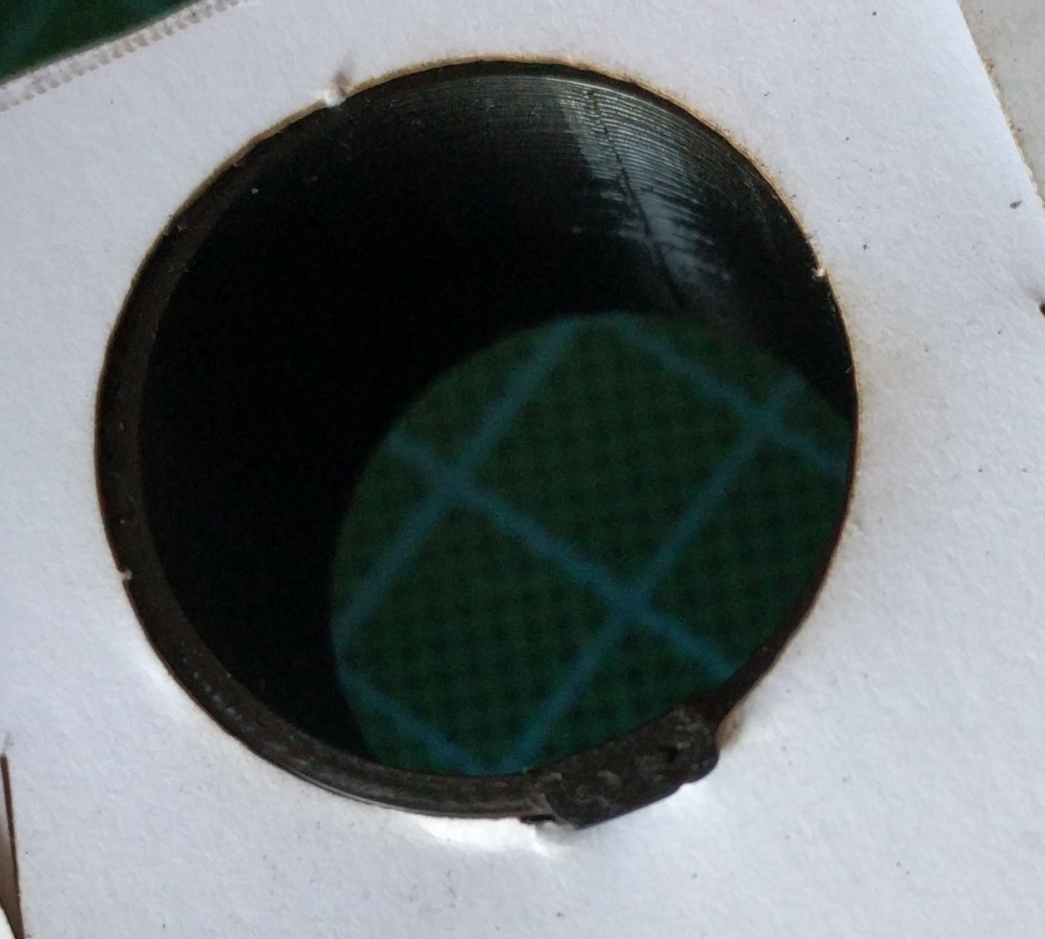

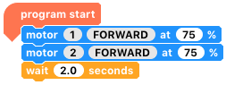
2) What do you think the following program will do? Run it and find out.
Hint: keep the battery pack off when programming it!

3) The % on motor blocks controls the speed. Investigate different amounts and see how it adjusts your drawing.

4) What happens when you change the wait statement?

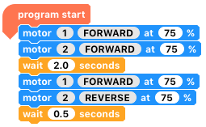

5) What does this code do? What happens when you change the last wait statement?

6) Can you finish the code so that it draws a line, turns around, and comes back again?

7) By combining multiple forwards and turns, we can draw shapes. Using the amount of time you had to wait for your buggy to turn around 180deg, you should be able to roughly work out 90deg.

A 90deg turn is ________ms

8) Can you use this information to draw a square?
Hint: use the ‘do () times loop’ block to repeat 4 times, so you don’t have to list all of the instructions for each individual side!

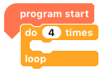

9) How would you adapt this code to draw a pentagon? A triangle?

10) How could you create something like this?

hint: nested loops (a loop within a loop)

11) What about drawing your first initial?

Where next?
There is a great deal of potential for line drawing, allowing the teaching of various programming techniques and mathematical concepts.

