Card Bot: Reverse Parking Sensor

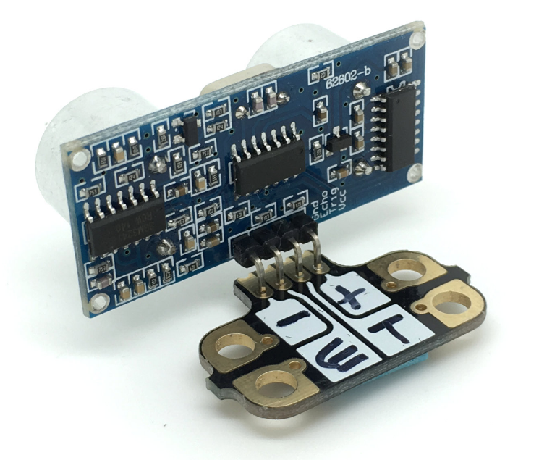
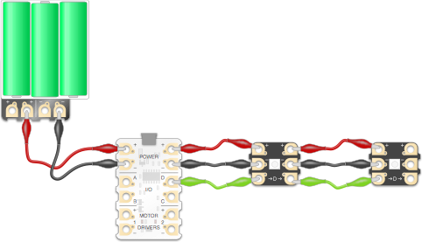
1) To get our parking sensor working, we first need to connect up our components. We need to connect the + and – on the ultrasonic distance sensor to the corresponding + and – on the battery pack.
Next, we need to connect the trigger(T) pad to A on the Crumble, and echo(E) to B on the Crumble.

hint: you can use any of the four I/O pads on the Crumble but leave D out if using Sparkles!

2) Now we need to connect the buzzer. Connect the + on the buzzer to C on the Crumble, and – on the buzzer to – on the Crumble.

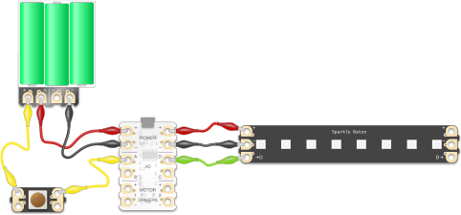
+

-

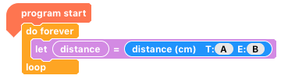

3) To check that our sensor is working, we are going to run a very short program. We will create a variable called ‘distance’. This should enable us to store the value read from the distance sensor.

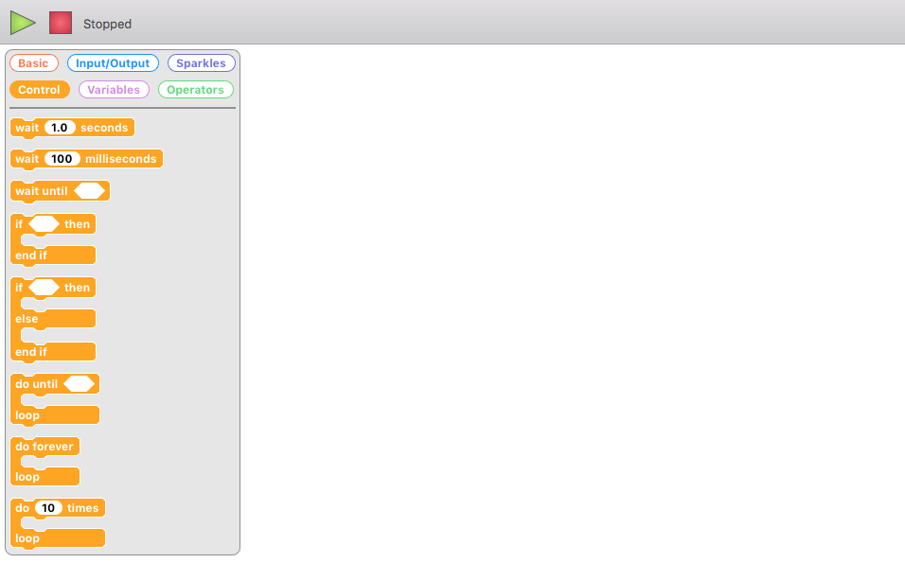
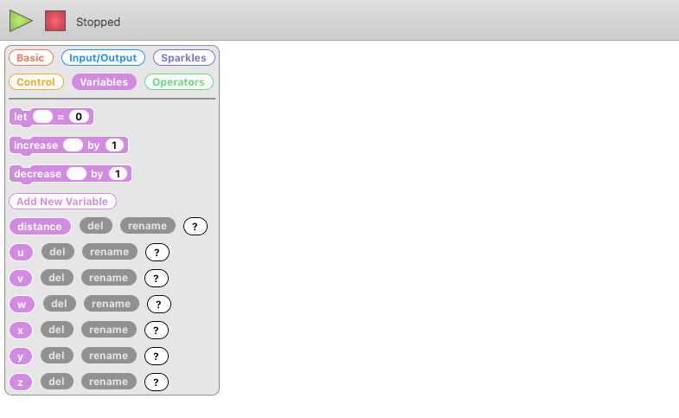
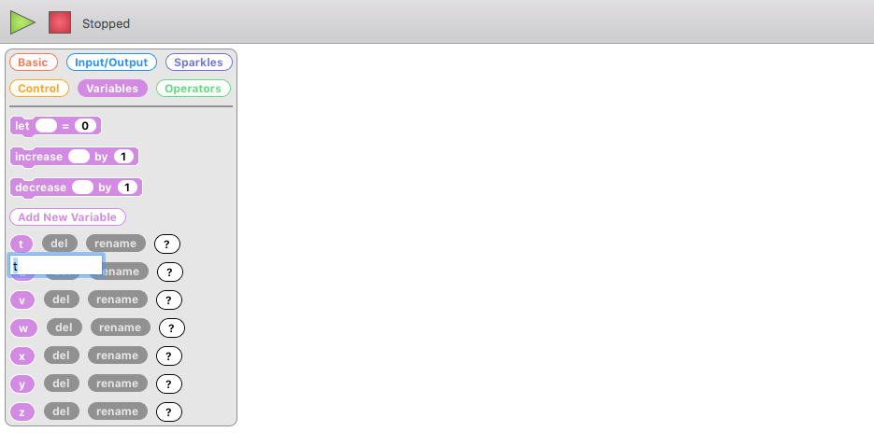
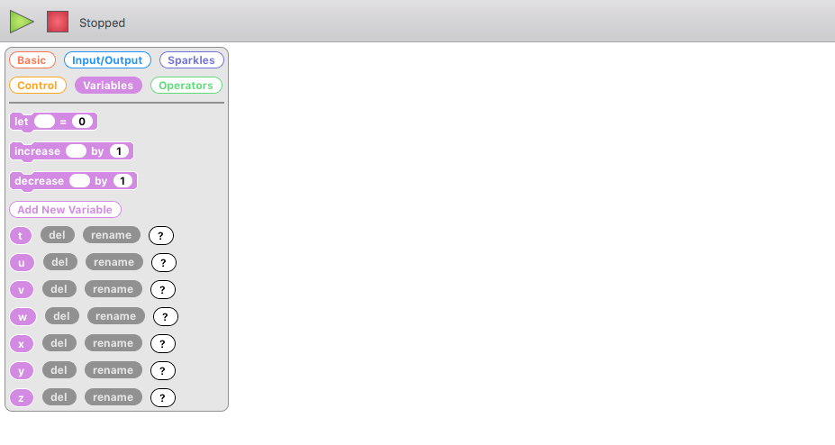
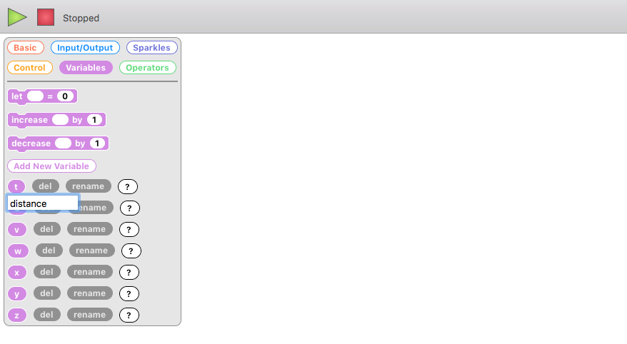

To rename a variable (and to monitor one when the Crumble is plugged in), click the ‘variables’ tab, click ‘rename’ to change the name of your variable and then hit the enter key or click on the white area on screen.

4) As you move your hand closer/further away from the ultrasonic distance sensor, the value of distance should decrease/increase.

5) Now we want to make something happen when the distance sensor detects something closer than 70cm. We will use an ‘if else’ block, with the condition ‘if distance > 70’.

If the distance is greater than 70cm, we want the buzzer to be off. If something is closer, then the buzzer will ‘beep’.

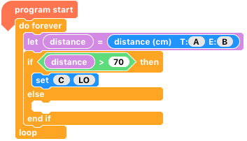

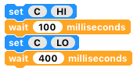
6) We can achieve a buzzer beep by setting C HI, waiting 100ms, and then turning it LO and waiting another 400ms. Can you place this within your program? Run the finished code and try moving your hand back and forth.

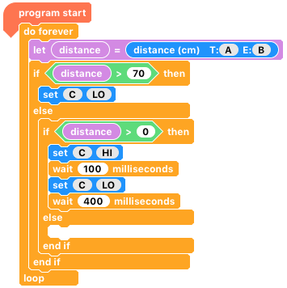
7) By using another ‘if else’ block, we can check whether the object is in between two distances e.g. 50 and 70cm. Can you fill in the values and make it beep quicker if it is less than 50cm away?

Hint: Think of the code in English.
If the object is further away that 70cm, do nothing.
Else, If the object is more than 50cm away (but less than 70cm), buzz once every 500ms.
Else, (assuming less than 50cm) buzz once every 300ms.

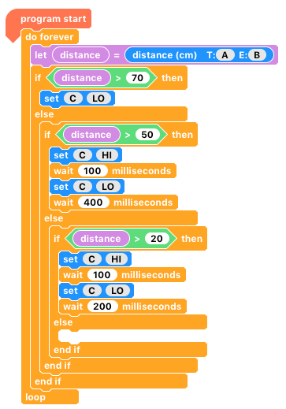

8) What about making the buzzer sound solidly if you are closer than 20cm?

9) Can you add a Sparkle to give you visual clues as to how close you are?

70cm
50cm
20cm

10) Can you add this to your buggy? What about making your buggy stop moving if it gets too close to something, or even turn away? (Extension to ‘Bump and Reverse’).

Where next?
The Ultrasonic distance sensor has a lot of possibilities, within numerous projects. It allows non-physical interactivity which can often be desirable. From automatic parking barriers to burglar alarms, the possibilities are endless!

