Card Bot: Line following

1) We need to connect our line follower up to the Crumble. Slot it into the holder on the front of the buggy (make sure the sensors are pointing to the floor). The + and – on the line follower need to connect to the corresponding pads on the battery box or Crumble.

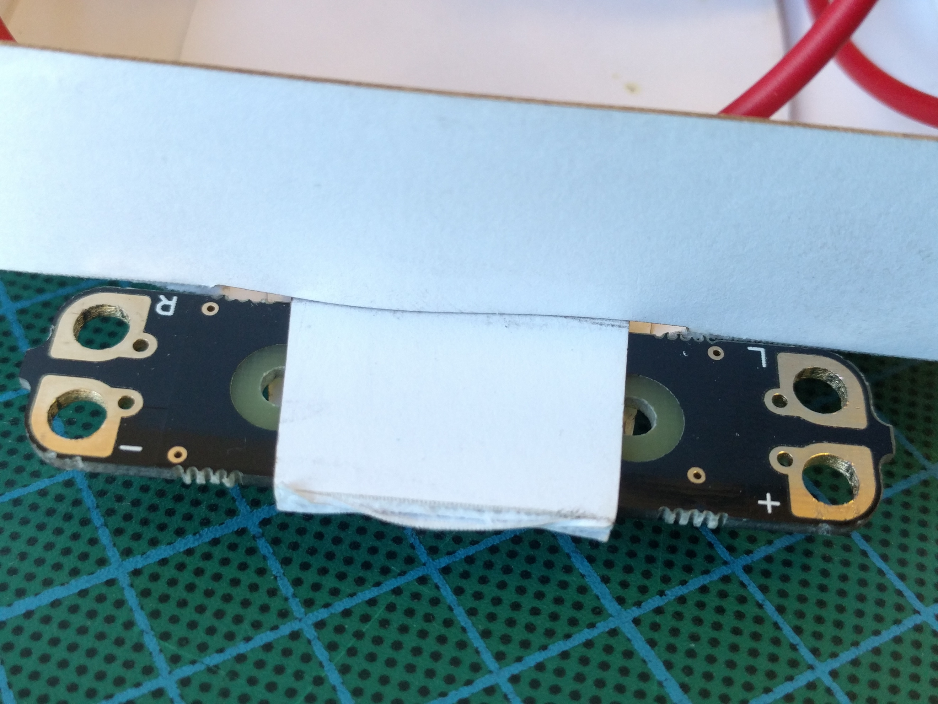
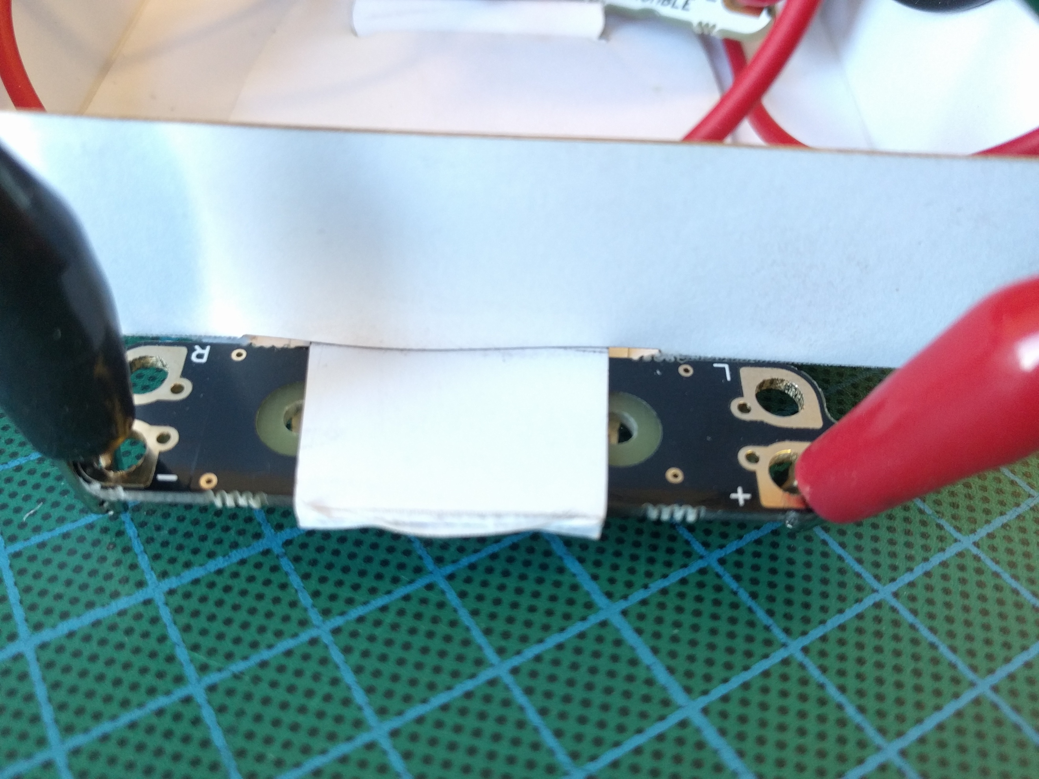

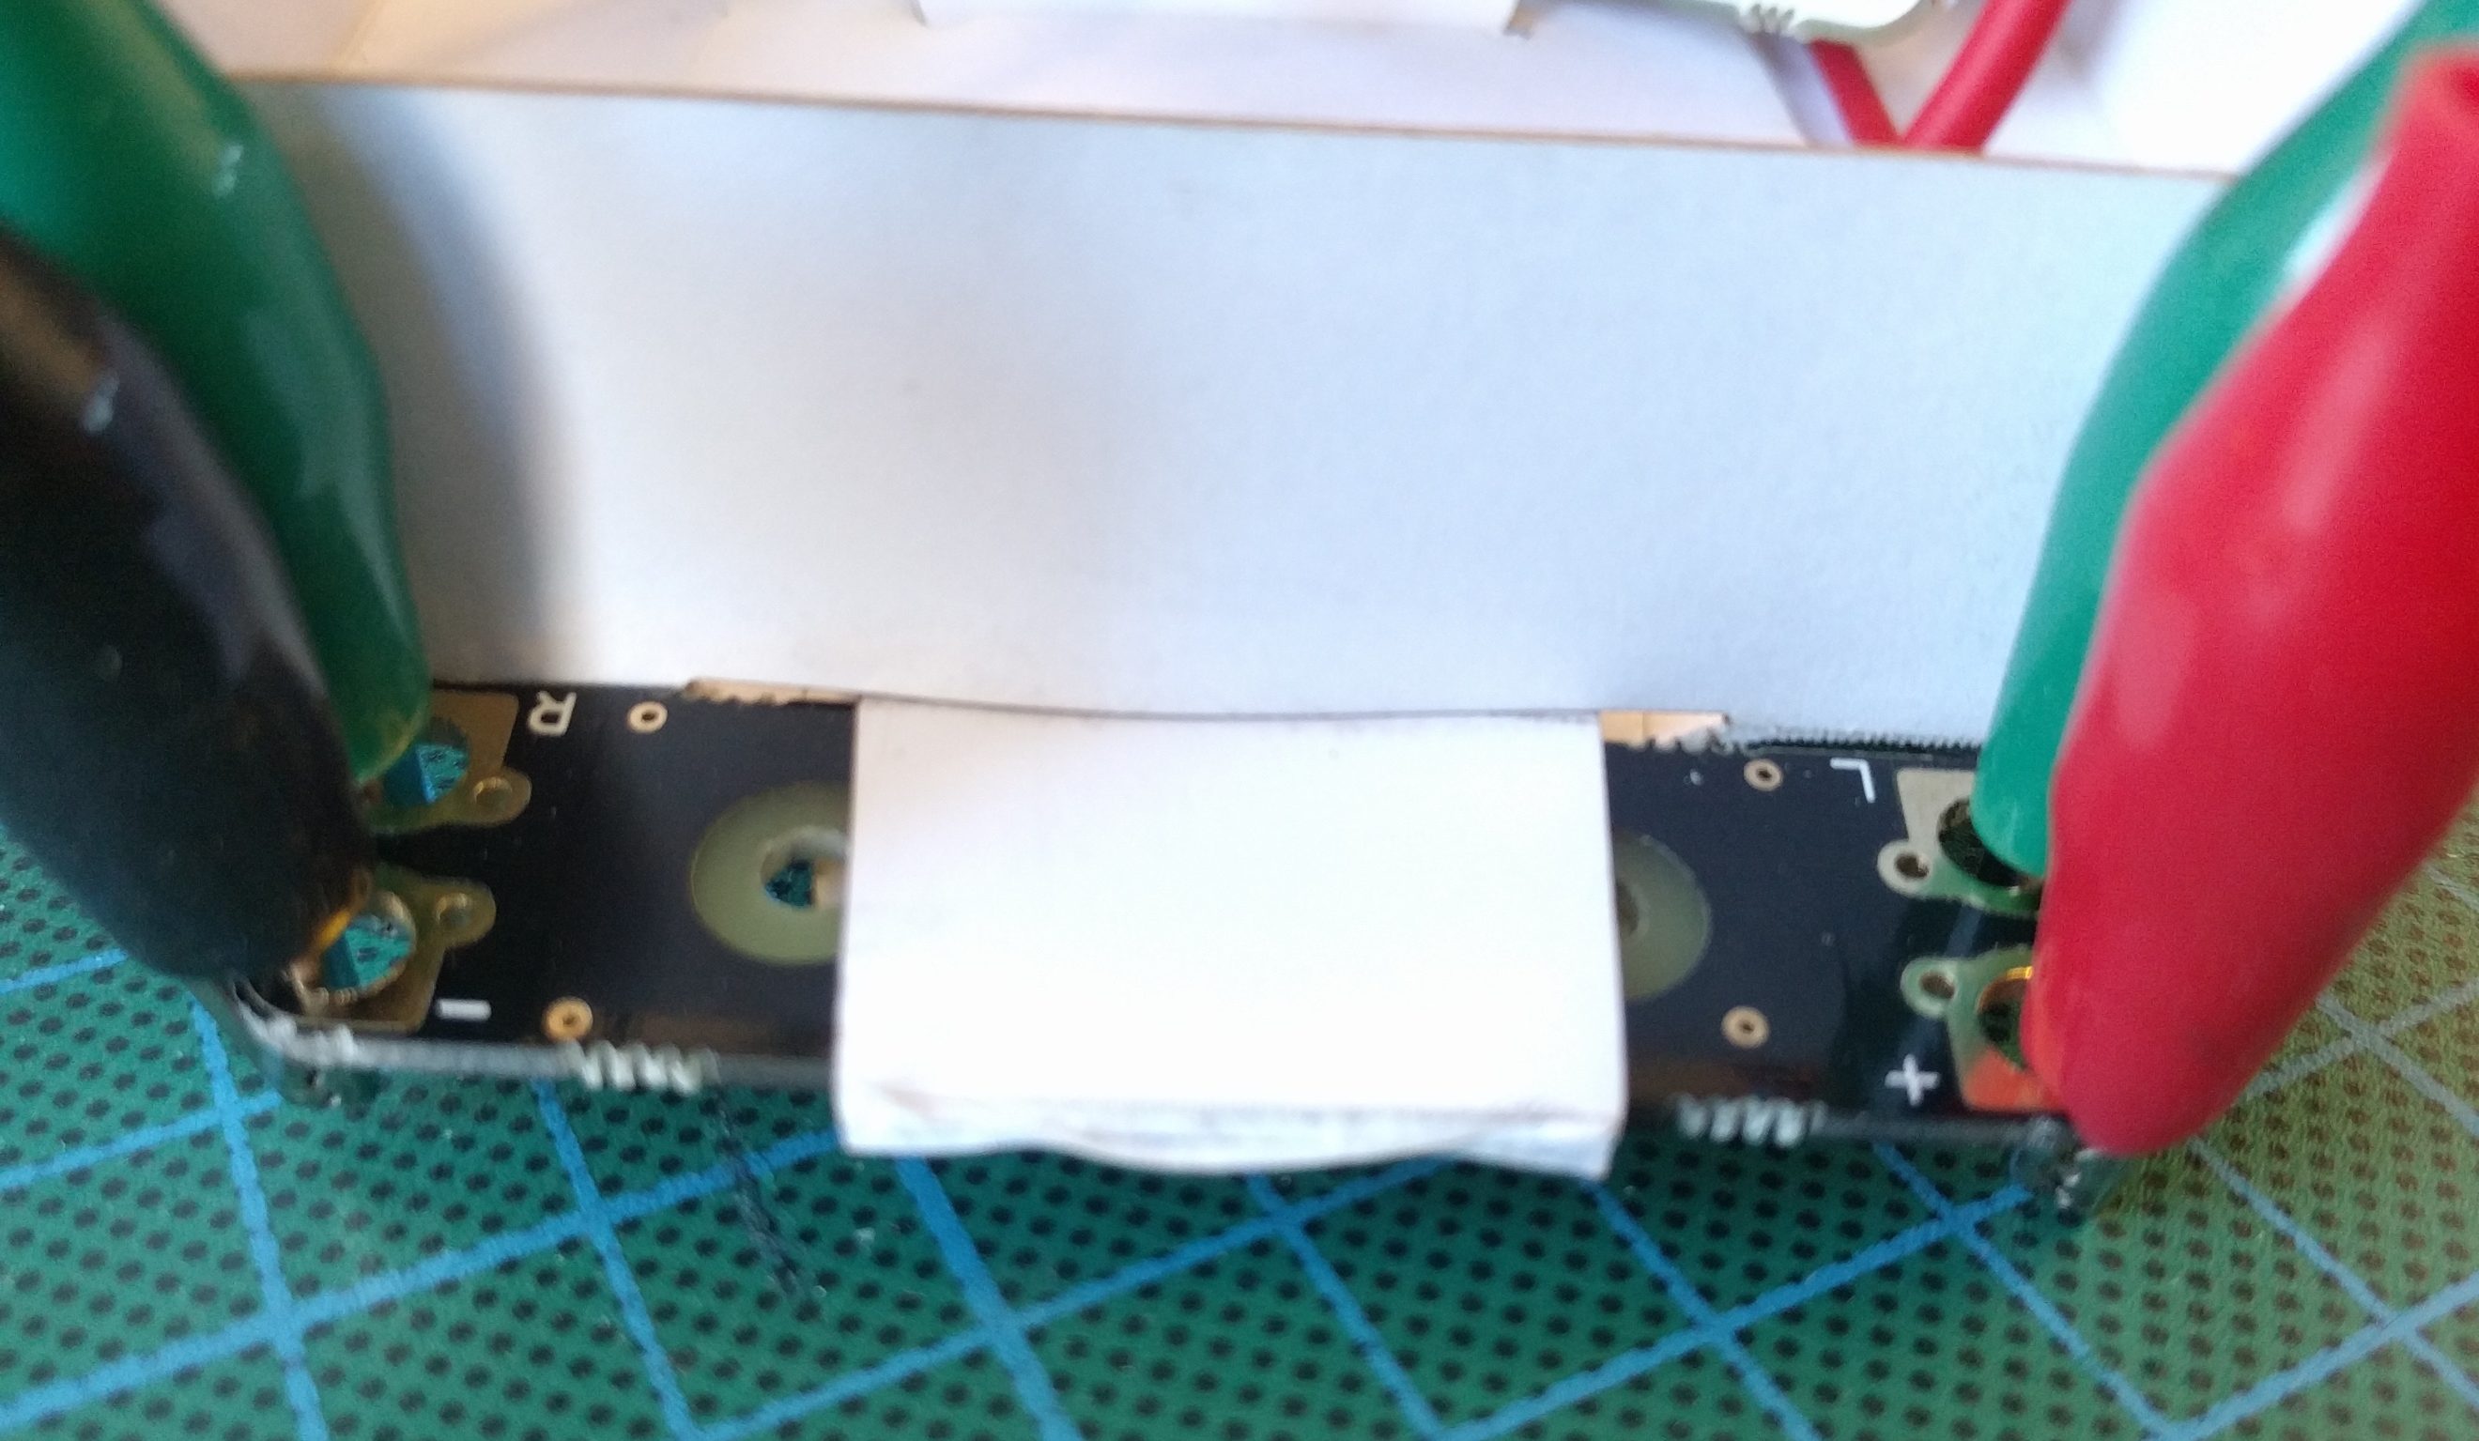
2) Then we need to connect left (L) to A on the Crumble, and right(R) to B on the Crumble.
hint: these can be any of the four I/O pads.

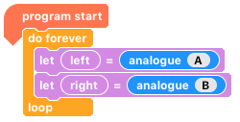

3) To check it’s working, run the following code. You should be able to see the two variables changing when you move the sensors over black/white.

4) When the left or right sensor of the line follower is over a light colour, it has less resistance, so a higher voltage is read by the Crumble. The darker the surface, the higher the resistance and the lower the voltage. To relate this to how we want the motors to behave, we need to think about the following:

Left Sensor | Right Sensor | Which way do I turn? | Left Motor | Right Motor
HI | LO
LO | HI
LO | LO
HI | HI

If the left sensor or right sensors are HI, which way do we need to turn? Which motor needs to be faster?

Before moving onto the next steps, can you think of a way (algorithm) to get the buggy to follow a line?

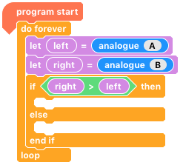
5) There are many ways to achieve this programmatically, but one of the more reliable ways is to compare the two. Can you fill in the gaps so that the buggy makes a gradual right/left turn depending on whether ‘right > left’ or else ‘left > right’. Try running it on a line.

hint: a gradual turn

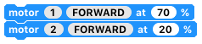

6) Hopefully your buggy followed the line! As you can see, we don’t need to make the buggy move forwards, by turning both motors at the same speed. The gradual turning causes a nice slalom movement along the line.

7) The last code was good for a shallow curve, and relatively straight tracks. But what if the track was a lot trickier? We need to look deeper at the values produced by analogue(A) and analogue(B). By setting up your buggy as follows and running the very first chunk of code, we can see what values are produces for light and dark.

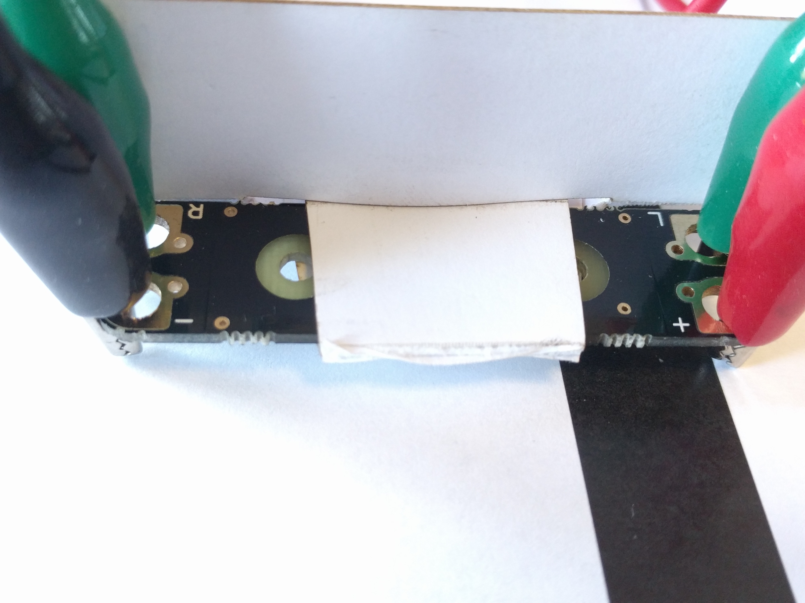
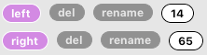

The chances are, everyone’s values will be different. But after checking both sides, we can make an assumption; the follower is on the line if it is less than 25 (you may need to alter this value).

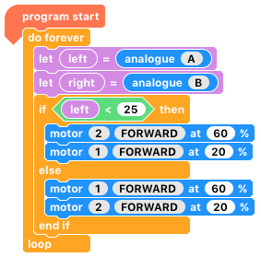

8) It’s easy to alter our code from before to take a different condition. If ‘left > 25’ gradually turn right. Else, gradually turn left.

9) This kind of project is easy to get started, but hard to perfect. Can you refine your code so that it will follow a more difficult course?

10) How would you adapt your code so that it would follow a white line on black paper? Can it work with other colour combinations?

Where next?
The simple, yet ingenious line follower isn’t just for buggies. It can be used to detect when something has opened e.g. a door as it works similarly to an LDR.

