 |  | LO: To use variables to control an output  Context: Spinning Santa  Success criteria:  - All children will have a motor spinning, using a variable value.  - Mastery: children will have used variables and a loop to control their motor and servo.  - Greater Depth: children will adapt their previous code to make it more efficient (see example for ideas)
 |  |  |  | 
Prior Learning:  Prior to this lesson, it would be useful if children have had experience using servos and motors. |  |  | Resources and Safety:  Along with Crumbles and computers, you will need: a battery box (NO rechargeable batteries), a gearbox with wheel, a servo with arm, 5 croc-leads. You will also need scissors, glue, sticky pads, corrugated card and a Santa sleigh. |  | Key Vocabulary:  The following terminology may be used: repetition, loop, variable, algorithm, output, nested loop.
  Teacher Input: | Explain to the class that they are going to be using and manipulating variables. What is a variable?
  Discussion: | Children discuss what a variable is and take feedback. Work through and discuss the examples on the presentation..
  Activity: | Children set up the Crumble, with a motor plugged into it. Can they create a variable, set it to a value and use the variable to control the motor speed?
Teacher Input: | Model the build to the children, and get them create their ‘Spinning Santas’.
Activity: | Children to create the ‘Spinning Santa’ model, following instructions from the teacher.

 | Teacher Input: |  | Now explain that we want to make the ‘Spinning Santa’ take-off and land. The motor needs to gradually speed up and the servo needs to gradually increase, so that the sleigh gets higher. This could then be followed by the opposite motion, so it ‘lands’. The motor and servo gradually decrease in speed/angle.
Activity: |  | Children work on creating their Spinning Santa which uses variables to take off and land (see fig. 1).  Greater Depth: Can children make the code more efficient? (shorter code – see fig. 2)
  Plenary: |  | - Allow children the opportunity to see how their peers’ projects differ (if they do) – especially focussing on the code.  - Get any children working on the greater depth task to show how they improved the code.  - Discuss how the use of variables can make tasks easier – imagine how long to code would be without it!
 |  | - Add other elements to the sleigh – e.g. red flashing Sparkle nose for Rudolph  - Improve the design  - Adapt it to make a fairground ride  - Write an adventure story involving Santa and his sleigh
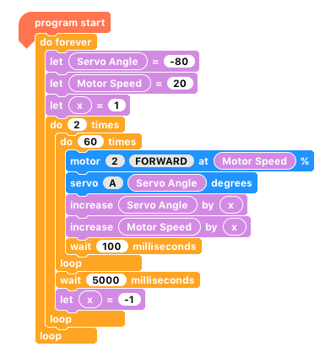
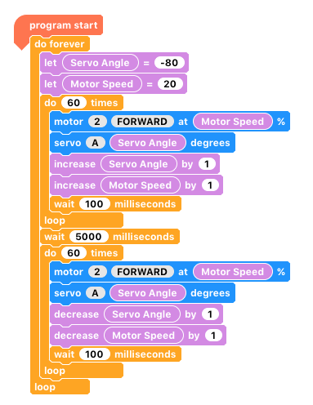
Fig. 2- a more efficient version of the code (notice the extra variable)
Fig.1 - The ‘mastery’ program – a take-off and landing effect.

