Date:
LO: To use variables to control an output

- What is a variable?
Variable

- What happens to the variable values?
4) What variables will you use?
Number of Coins Health value
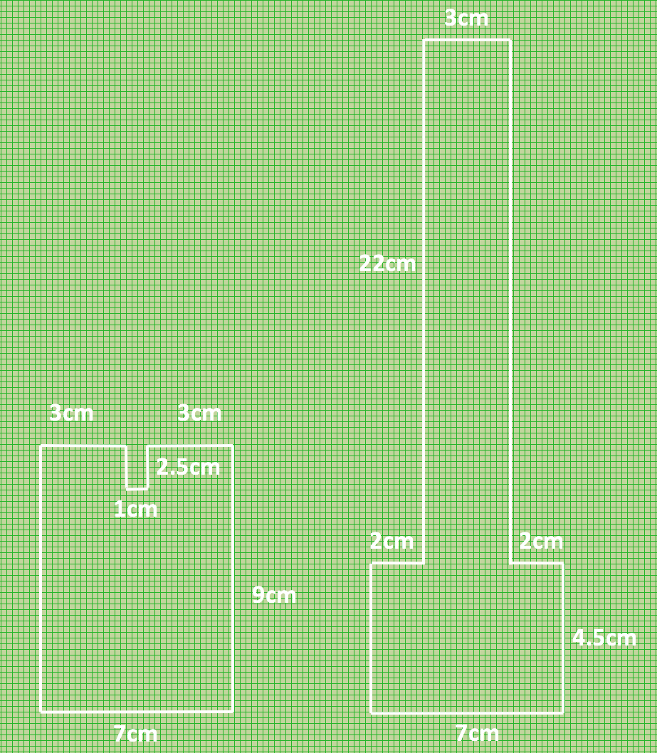
- Useful dimensions:

