Date:
LO: To make and program a 7-segment display

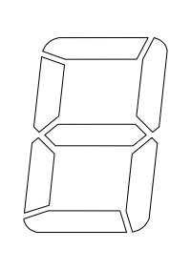
1)
9
6
7
8
3
4
5
2
1

0

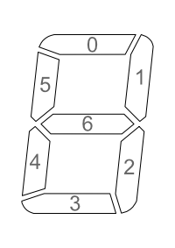

2) Which Sparkles do you need to light to make each number?
hint: use the diagram to help

Number | Sparkle Number
Number | 0 | 1 | 2 | 3 | 4 | 5 | 6
Zero
One
Two
Three
Four
Five
Six
Seven
Eight
Nine

3) Watch carefully and make your 7-segment display.
4) Wire your display up.
5) Program your display to do a 9 second countdown, from 9 – 0.
Greater Depth: Can you use a form of input (think switch etc) to control and reset the timer?

