Date:
LO: To use an input and selection to control an output
- What would the algorithm for a nightlight be?

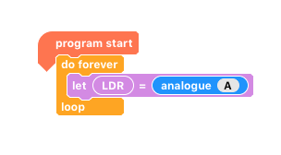
- Connect the LDR to A and run the following program:

What happens when you cover the LDR? Look at the value of the variable.
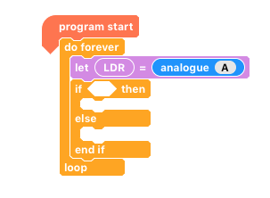
- Can you make your own automatic nightlight? Use the following skeletal-code as help.

- Can you make a nightlight using a variety of colours?

Greater Depth: Can you make your nightlight gradually fade between colours?

Hint: you’ll need to check regularly whether it’s light!

