Date:
LO: To programmatically control a mechanism

- How do you think the eyes work in the moving eye picture?

- How could you use the Crumble to control the mechanism?

- What is a servo? How does it work?

- Draw the block that you control the servo with

- After wiring up your portrait, work out the ‘limits’ of the servo for your picture.
My servo can safely go from ____ to ____.

- Now look at how we can use a variable to set the angle we want the servo to turn to.
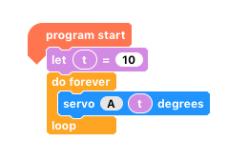

- Now make your portrait move its eyes from one side to the other. You could even add in a stop in the middle.

- Greater Depth – We want the eyes to move smoothly from one side to the other. How can we achieve this using variable(s) and as efficiently as possible?

Plenary and reflection
- Compare your program/code with a neighbour. Does it look different to yours? Why?

- What would you do to improve your work?

- How could you use this in a future project?

